**Servlet & JSP & web server**

**Interview Question For Servlet java**

Q1.How many objects of a servlet is created?

Ans. Only one object at the time of first request by servlet or web container.

Q2. **What is the life-cycle of a servlet?**

**Servlet is loaded, Servlet is instantiated, Servlet is Initialized, Service Request, Servlet destroyed**

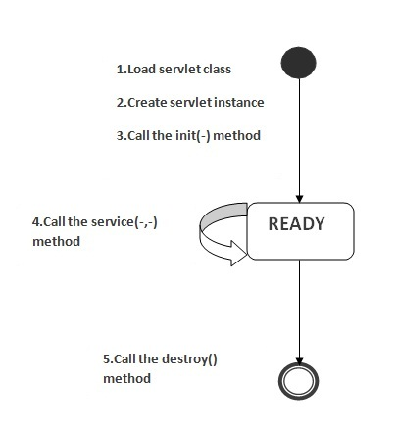

**Q3.What are the life-cycle methods for a servlet?**

* public void init(ServletConfig crvletException) : It is invoked only once when first request comes for the servlet .it is used to initialize the servlet
* public void service(ServletRequest request,servletResponse response) throw ServletException, IOException : It is invoked each time for used to service the request.
* public void destroy() : It is invoked when servlet is unloaded

**Q4.  Who is responsible to create the object of servlet?**

The web container or servlet container.

**Q5. When servlet object is created?**

When first request comes to servlet.

**Q6.  What is difference between Get and Post method?**

**GET:**

* limited amt of data can be send and because data is send via header.
* Not Secured because data is exposed in URL.
* More efficient & Used than post.
* Can be bookmarked

**POST:**

* Large amt of data can be send because data is send in body.
* Secured
* Less efficient and used
* Can’t be bookmarked

**Q7.What is difference between Print Writer and Servlet Output Stream?**

**Print Writer is a character-Stream class and Sevlet Output Stream is a byte stream class.**

Print Writer can used to write byte stream but Servlet Output Stream can used to write byte Stream as well as primitive values.

Q8. **What is difference between GenericServlet and HttpServlet?**

* GenericSevlet is a protocol Independent and HttpSrvlet is protocol specific.
* HttpServlet provide extra functionality such as state management.

**Q9. What is servlet collaboration?**

When one servlet communicates to another servlet.

There are many way to servlet collaboration:

1. sendRedirect()
2. RequestDispatcher()

* forward(ServletRequest req, ServletResponse res)
* include(ServletRequest req, ServletResponse res)

**Q10. What is the purpose of request dispatcher?**

* RequestDispatcher is also called Intrceptor .
* RequestDispatch provides the facility of dispatching request to another resource it may be html, jsp servlet. This is also be used to include the content of another resources.

**Q11. Can you call a jsp from the servlet?**

By RequestDispatcher interface.

Ex. RequestDispatcher rd = request.getRequestDispatcher(“/login.jsp”);

rd.forward(request, response);

**Q12.Difference between forward() method and sendRedirect() method ?**

**forward():**

* Forward() sends the same request to another resources.
* Forward() works at server side.
* Forward() words within server only.

**SendReDirect():**

* sendRedirct() always sends the new request because it uses the url of browser.
* Works at client side.
* Works within and outside the server side

**---------------------------------------------------------------------------------------------------------------------**

**ServletConfig Interface:**

An object of ServletConfig is created by the web container for each servlet. This object can be used to get configuration information from web.xml file.

**Methods of ServletConfig interface:**

* **public String getInitParameter(String name):**Returns the parameter value for the specified parameter name.
* **public Enumeration getInitParameterNames():**Returns an enumeration of all the initialization parameter names.
* **public String getServletName():**Returns the name of the servlet.
* **public ServletContext getServletContext():**Returns an object of ServletContext.

**JSP**

**JSP Action Tags**

1. The **jsp:forward** **action tag** is used to forward the request to another resource it may be jsp, html or another resource.
2. The **jsp:include action tag** is used to include the content of another resource it may be jsp, html or servlet.

The jsp include action tag includes the resource at request time so it is **better for dynamic pages** because there might be changes in future.

**Interview Question For jsp**

**Q1. How to disable session in JSP?**

<% @page session=’false’ %>

A **web container** is the component of a web server that interacts with Java servlets. A web container is responsible for managing the life cycle of servlets, mapping a URL to a particular servlet and ensuring that the URL requester has the correct access-rights.

**Q: Differences between a Web container, Web server, servlet container and an application server?**

Typically, a Web server refers to an execution infrastructure that handles HTTP requests and responses; a servlet container refers to a component that handles the lifecycle for servlets; an application server refers to a framework (servlet container, EJB container, JSP engine, MQ container, etc.) for handling Web applications. However, a Web container has a couple of meanings depending on the source. Most refer to a Web container as the part of an application server that manages servlets, JavaServer Pages (JSP) files, and other Web-tier components. Some refer to a Web container as the infrastructure for managing the lifecycle for Web services.